ON FOOT
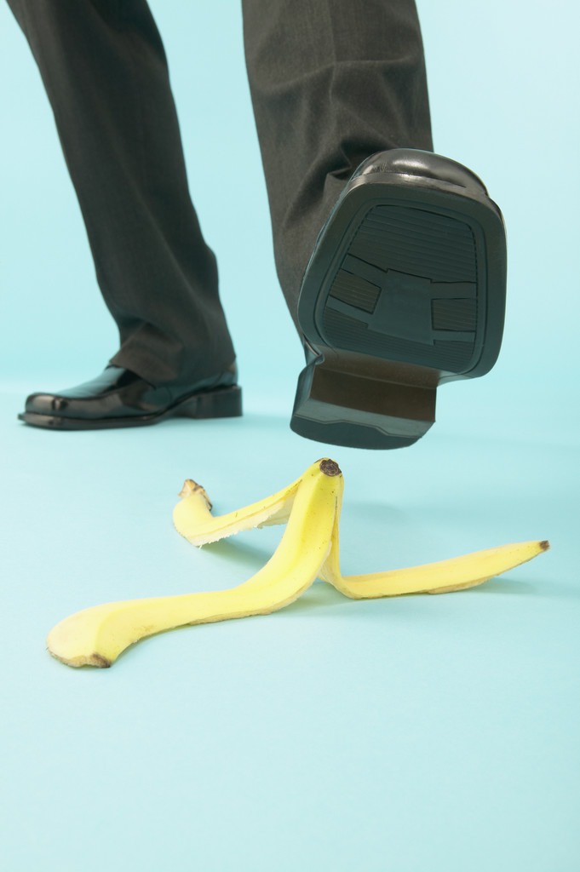

Walking on foot has many advantages and disadvantages. I like walking on foot because I can watch the world, meet a lot of unknown people and get to know them. I can breathe fresh air, as well. I like listening to music during walking. It´s free. I don´t have to wait for anything.
But when I walk on foot I can hurt myself. I can twist my ankle or the car can hit me. Walking on foot takes a lot of time and energy. It is very slow, too. I can get wet, tired and I can lose my way.

TRAM
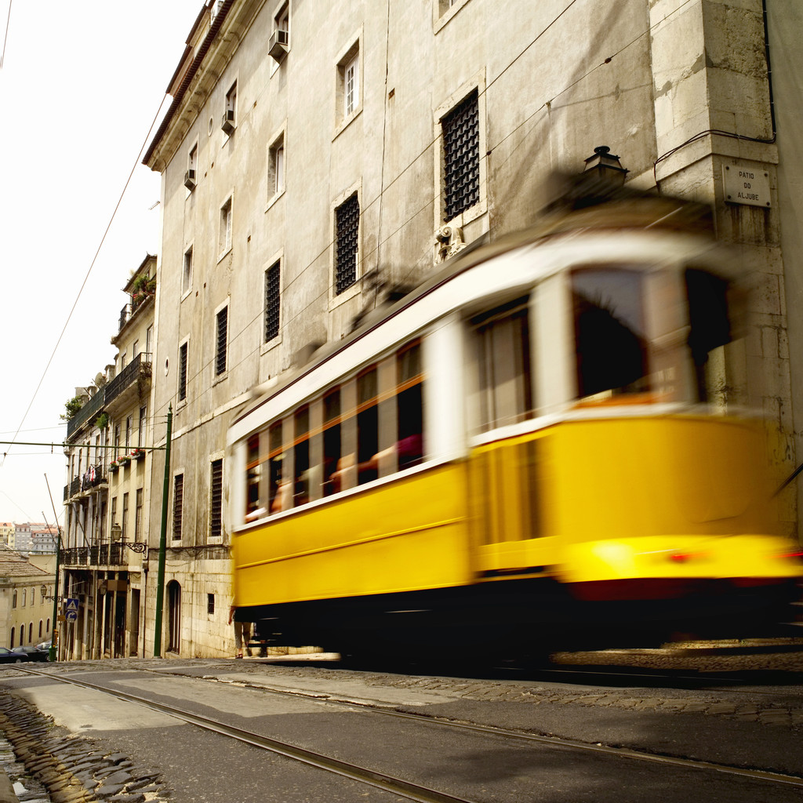
Travelling by tram has many advantages and disadvantages.
The advantages are: There are no stressful traffic jams and trams are comfortable. You can sit, but sometimes you don´t have to. You can read books or watch the world going by. You can see and recognize many new people around you. You can eat your snack and you don´t have to take a steering- wheel. You can get in or off when you want. The trams aren´t very expensive and you need´t walk.
The disadvantages are: The trams are sometimes crowded and delayed. You have to travel at certain times and trams cannot také you from door to door. You have to buy a ticket and go to the platform.
I prefer travelling by tram to travelling by car because I don´t have to také a steering wheel. You can sit and relax, too.

UNDERGROUND
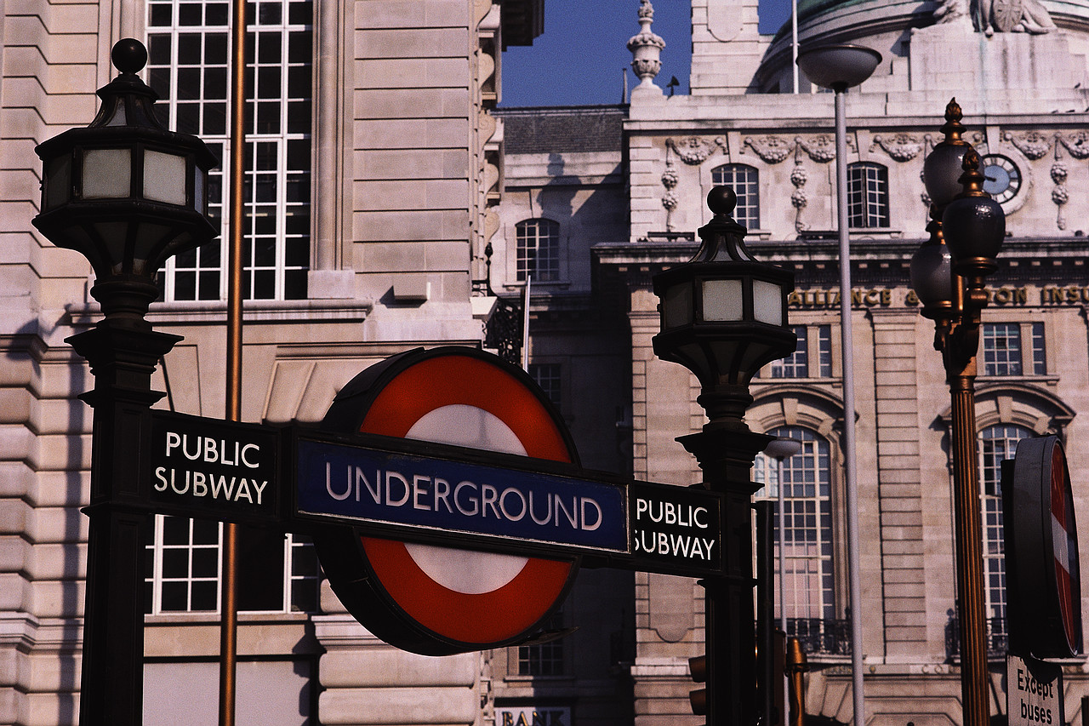
I think that underground is better than the bus or tram because it is very fast and cheap. It is quiet and you can find it only in big cities where many people live. It is quiet safe and you can get tickets at the ticket offices or from a slot machine.
The negative is that it can be dangerous because of an earthquake. There can be bombs and terrorists or explosions, there is little air. Sometimes it can be very crowded and dirty and very dark- you cannot see anything out of the windows.

BALLOON
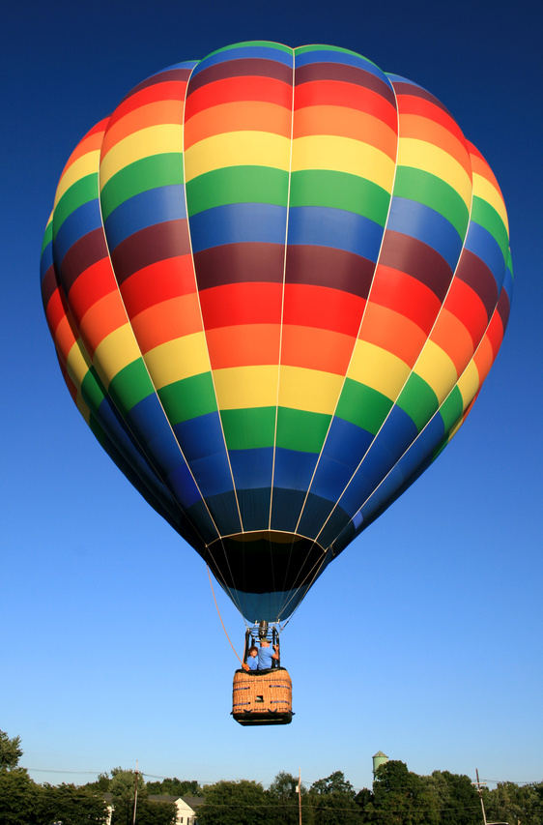
I have never travelled by balloon, but I think it is amazing, exciting and like in a fairy tale. Balloon is never crowded, you can watch the world going by. It is very romantic for me. On the other hand, balloons are slow and in Slovakia they are used
only as an attraction. A few people can travel together.

BUS
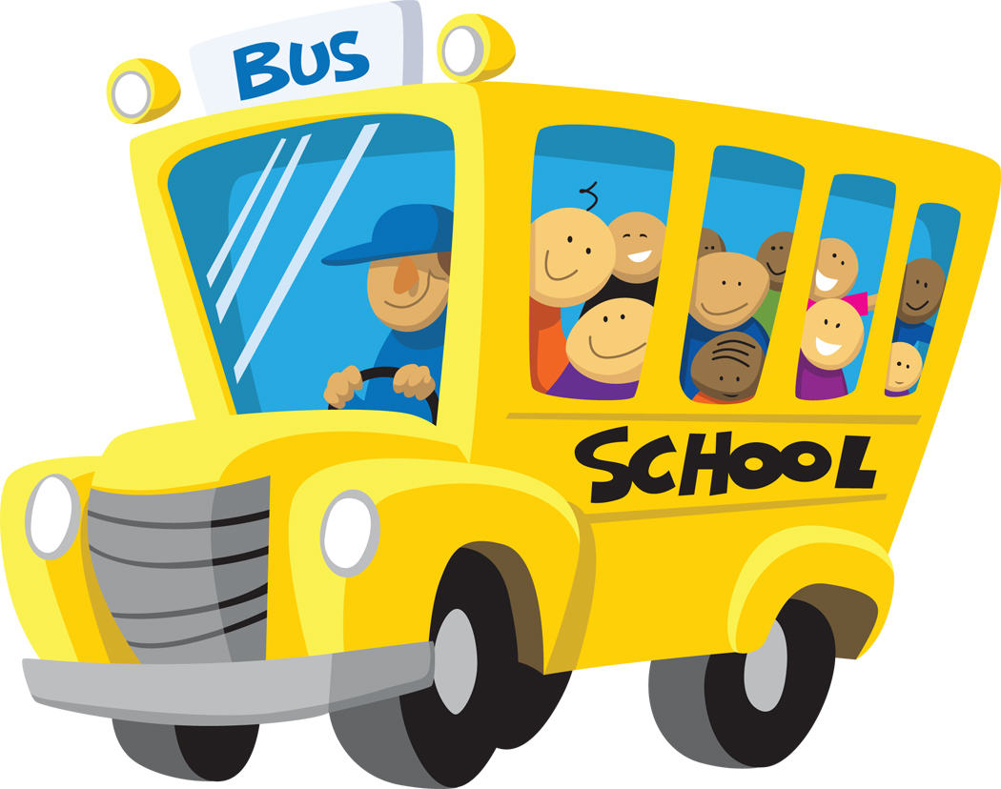
Travelling by bus isn´t very fast and we can use the time in many different ways. We can just sit and read, eat, drink, look at the countryside, sleep, listen to music or talk to your neighbour. Travelling by buses especially coaches is quite polular nowadays. Buses are usually equipped with better seats and a dark glass. Some buses offer food and drinks.
This kind of transport has disadvantages, too. For example, it isn´t comfortable, it is expensive and sometimes delayed. Bus is crowded and can get stuck in a traffic jam. Buses in our country are sometimes dirty and one of the problems is a lack of maintanance, too. Very often there are only a few free seats. Moreover, buses stop on every bus station.
I hate travelling by bus because I don´t feel very well in the bus.
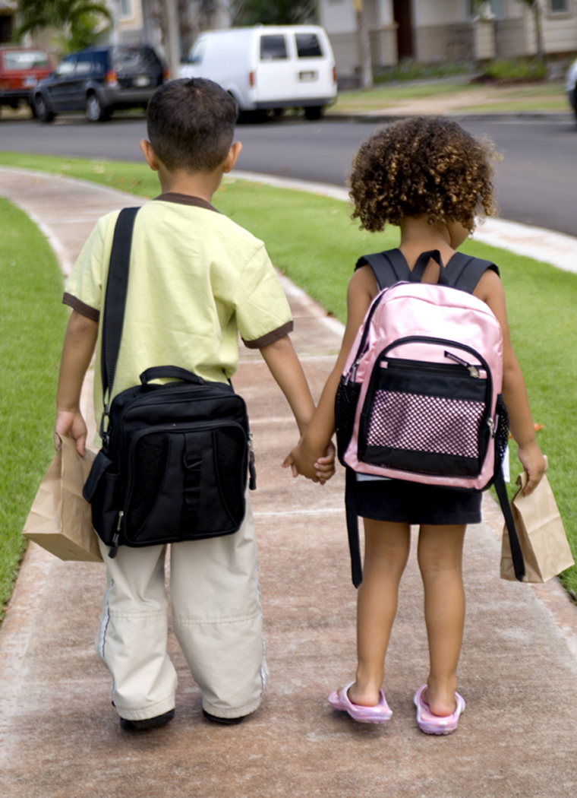
THE BRITISH SCHOOL SYSTEM
Educational system in England, Scotland, Wales and Northern Ireland differs.
British children begin their education at the age of 5 and must attend school to the age of 16/ so children have 11 years of obligatory school together.
Some go to nursery school from the ae of 3 to 5. In nursery education small children in Britain may attend creches and later kindergartens.
At the age of 5 English children start their primary education and when they are 7, they move from infant to junior primary school.
At the age of 11 they can continue at secondary school. There are many types of secondary education/e.g. secondary modern school (they provide general education and focus on more practical activities), grammar school for talented students(they prepare students for university study), technical schools (which put emphasis on education in the industry area, commerce and agriculture), comprehensive schools- which are non-selective and are for children of all abilities. Comprehensive schools provide general education. These end at the age of 16, most pupils take public exam in 7 subjects/ GENERAL CERTIFICATE OF EDUCATION {GCSE} EXAMs / are national and give students a qualification that is recognised across the whole country.
After that they can leave school and start work or go for vocational training. But if they want to study at a university, they have to stay 2 more years- they attend the sixth form and take A/level exams in 2, 3, or 4 subjects. Students who have passed this exam may go to university polutechics or colleges of higher education.. According to the results, universities choose their students. Britains oldest and most famous universities are Oxford and Cambridge- Oxbridge. Stulets receive grants for course fees and their living expenses like food, accomodation, ot they can get loans. They get bachelor´s or master´s degree and later doctor´s degree.
In Britain there are state schools and private schools. 94% attend state schools-they are free of charge. There are many private schools in Britain, mainly for the 11-18 age group. Public schools are private boarding schools which are for children aged 13-18 accepted on the basis of the entrance exams. Only 5% of all children attend public schools- they are very expensive with a long tradition, e.g. ETON, HARROW, RUGBY, WINCHESTER... They are often single sex.
The academic year begins at British primary and secondary schools in September and finishes at the end of July. It is divided into 3 terms. Christmas and Easter make intervals between them. Children have 6 week holidays in summer, 2 weeks during Christmas, 2 weeks at Easter. There are 2 week holidays in the middle of each term. Day schools work from Mondays to Fridays. Classes are held from 9 a.m. to 4 p.m. and the day is usually divided into periods of about 35 minutes ( 60 at some schools). The average nimber of pupils in a class is 30.
Extra curricular activities are very important. There are many different clubs and sport teams. Many schools have an orchestra that gives concerts or a dramatic group. Pupils in Britain wear a school uniform- shirt, skirts, trousers, jacket, tie. Each school has a different one with its symbols.
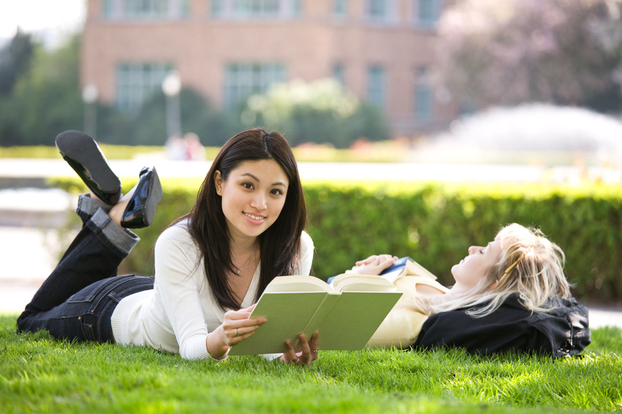
Subjects learned at B. schools: English, modern languages, maths, chemistry, physics, biology, geography, history, music, arts, P.E., R.E., technology, I.T., assembly, registration- every morning.
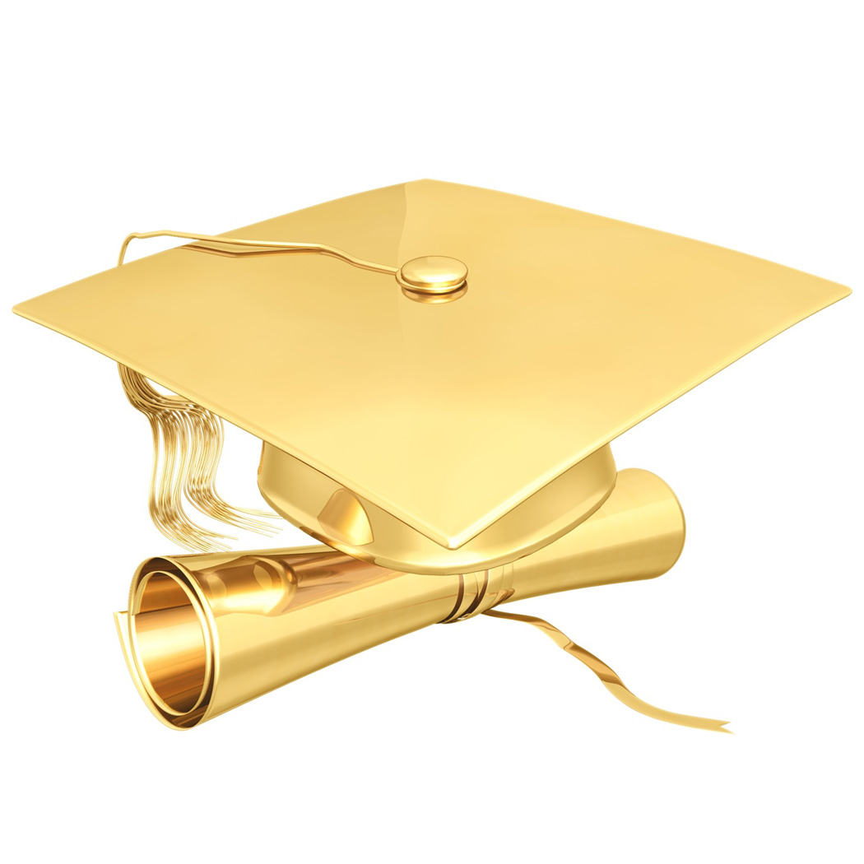
THE SLOVAK SCHOOL SYSTEM

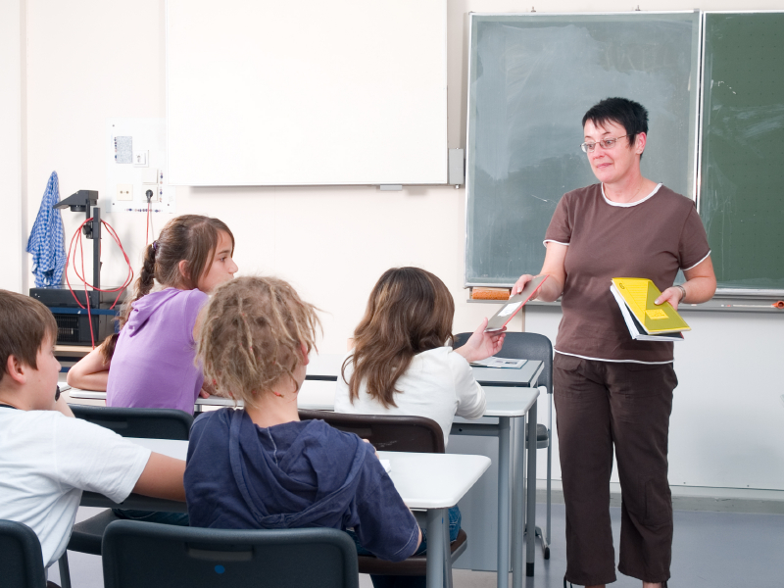
There have been some changes made in the educational system in Slovakia in the few last years. The National Curriculum has been changed, a new school-leaving exam was being introduced at secondary schools in 2005, many students are taking advantage of studying abroad and Bachelor´s and Master´s degrees were introduced. There are several stages of education: pre-school education, primary education, secondary education, post secondary education and higher education.
PRE-SCHOOL EDUCATON: The child from 1 to 3 years of age could attend a day nursery and from 3 years of age and then kindergarten. In kindergartens, children learn some basic skills like recognizing colours, animals, plants, numbers and letters. Also, they learn to draw, paint, sing and say simple poems. Most of Slovak children, however, stay at home with their mothers up to 3.
In Slovakia school attendence is compulsory from the age of 6 when pupils start at the age of six and finish at 15. Most schools in Slovakia are state schools which are free of charge. In addition, there are private schools where tuition fees are charged. Most of them offer a specific type of education- specializing in foreign languages or sports. Education is provided by religious schools, too.
ELEMENTARY SCHOOL (primary, basic) - 6-year-old children begin their compulsory 9 -year school attendance. Primary education is divided into 2 stages: the first stage with grades 1-4 and the second stage with grades 5-9. However, some students star their studies at 8- year grammar schools as soon as they finish 5th grade of primary school. Children have from 25 to 30 lessons per week. Schools in Slovakia are co-educational.The school year begins on September 1st and finishes on June 30th. Children gradually learn to read, write and count, later they are acquianted with the basics of history, geography, the natural sciences- biology, chemistry, physics, maths, IT and arts like music, art, then ethics, RE, PT. At the end of each school year pupils get reports with their academic record in different subjects. Pupils are given marks at schools- 1 is the best mark and 5 is the worst one. If a student gets a 5 in June, he can take a make-up exam to try once again to pass. Lessons last 45 minutes, there are 5, 10, 15 or 20 minutes breaks. Pupils have many holidays- 2 months in summer, 2-3 weeks at Christmas, 1 week at Easter and spring. As well, there are a few free days on state holidays. Students can have lunch in a school canteen or a cafeteria. Classes are held in special laboratories for physics, chemistry, biology, IT, ethics or in a gym, fitness centre or playground for PE lessons. Schools may also have a large assembly hall where meetings and celebrations are held. Hallways and staircases are decorated with flowers and pictures of famous people from the world of education and science. There are also notice-boards with important information for students. Children put their clothes and shoes in cloakrooms or lockers.
SECONDARY SCHOOL- After finishing primary school – after 9th grade- we can choose from various options- to study at secondary school which takes 4 years (industrial, medical, economic, business, technical), apprentice training (mechanical, engineering, electro-technical, building, agricultural) or art school. At apprentice school they get a certificate and become qualified workers and craftsmen.
One of the alternative secondary schools is grammar school which prepares its students for university studies. Its study can last 4 or 8 years. Those students who would like to study at grammar school have to take entrance exams. There are also vocational schools – their training prepares students for different kinds of professions, like business, technical study, medical school. The study lasts either 3 years and finishes with achieving skill certificate, or 4 years which ends with school leaving exam called MATURITA. The five-year study programe is sometimes bilingual.
At the end of 4th year students must pass a graduation examination consisting of oral and written part. School leaving exam consists of 4 subjects: compulsory is Slovak and 1 foreign language, 2 other are optional. Written part is compulsory for Slovak language and literature, 1 foreign language and maths.
POST –SECONDARY EDUCATION- is non- university education and it is a new trend in professional education, specialising in such fields of study as accounting, information processing, computer technology, tourism and entrepreneurship. The study lasts 3 years and is completed by final exams.
UNIVERSITY- Higher education lasts from 4 to 6 years. If we want to study at university we must successfully pass the entrance exams and interviews. We can choose technical, humanitarian, economic, journalism, law, engineering, drama, fine art, medical orientation or conservatory. Applicants can decide whether they want to study part time or full time. The largest and oldest Slovak university is Comenius university in Bratislava. During university studies many students decide to spend a term or a year at a foreign university as Exchange students. – it is an excellent opportunity to make some Money, speak a foreign language, see new cultures, meet new people, live independently and be self-confident. After 3 years of study at university we can get the academic title of bachelor, after 2 more years master´s degree and later doctor´s degree. One of the most famous universities in Slovakia is Comenius university, The university of P.J. Safarik in KE, the Matej Bel university in BB, the Technical university in KE.
There are also specialized schools like driving school where students learn how to drive a car, motorcycle, truck or a tractor. Next, there are special schools for children with mental or physical handicaps, arts schools for talented musicians or singers or language schools for learning languages.
